5.31:
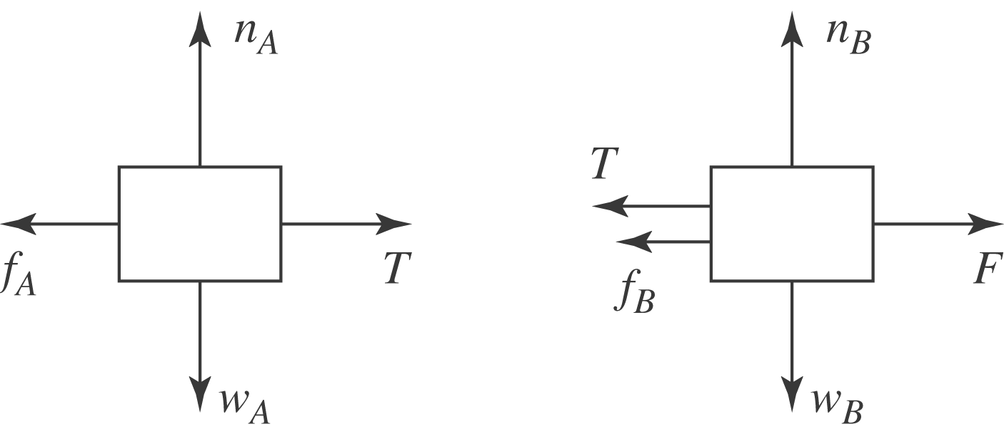

a) For the blocks to have no acceleration, each is subject to zero net force. Considering the horizontal components,
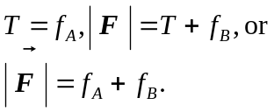
Using 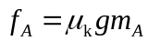 and 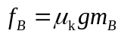 gives 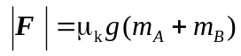.
b) 